Chapter 4, Solution 54

To find V_{Th} =V_{x}, consider the left loop.

(1)
For the right loop,
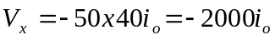 (2)
Combining (1) and (2),
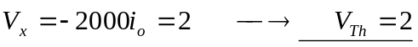
To find R_{Th}, insert a 1-V source at terminals a-b and remove the 3-V independent source, as shown below.

1 k i_{x}
.

i_{o} + + +
2V_{x} 40i_{o} V_{x} 50 1V
- - -

